

1

Women in History Scholarship

**Student Application**

2025 - 2026

2

**CONTEST INFORMATION**

**Eligible:** Living in San Diego County, Female senior in High School, who has been accepted and

signed a letter of intent to attend a College or University.

**Application Deadline**: Interested students must submit an essay, application, proof of college acceptance and/or attendance, photograph suitable for publication and liability release form to their La Mesa/El Cajon AAUW CA Branch by midnight March 31, 2025

**Essay:** 500-1000 words expressing “Why are you applying for this scholarship”, based on the purpose of the scholarship.

**Judging:** Judges shall use the official ballot and score each 500 - 1000 word essay accordingly. Content should include Introduction, Organization and Conclusion.

**Award and Presentation:** The scholarship recipient will be asked to attend the May La Mesa/El Cajon Monthly meeting to accept their scholarship and give a short overview of their future interests (approximately 5 minutes).

**Prizes**: Each awardee will receive between $500.00 - $1,000.00 award this will be determined by the scholarship committee.

**STUDENT APPLICATION**

**Student Name:**

**Email:**

**Phone:**

**High School Attending:**

**College or University you will be attending:**

***Student Signature: ________________________________________________________________ Date: __________________***

Please return this application and essay to your local branch contact:

La Mesa/El Cajon AAUW Branch Contact is:_Sandra Galea-Martinez Phone(619)244-3053_ Email__sagaleamartinez@gmail.com_

3

**Purpose:** Supporting young women interested in pursuing a career in the area of advocacy, research, and/or education related to women’s studies, women’s history, social, political, and/or environmental change.

Additionally, if she has non-profit, volunteering experience and/or club experience in these areas, it may be beneficial.

**Essay Prompt:** **“Why are you applying for this scholarship” (insert essay here or attach with submission)**

4

Judging Form (example)

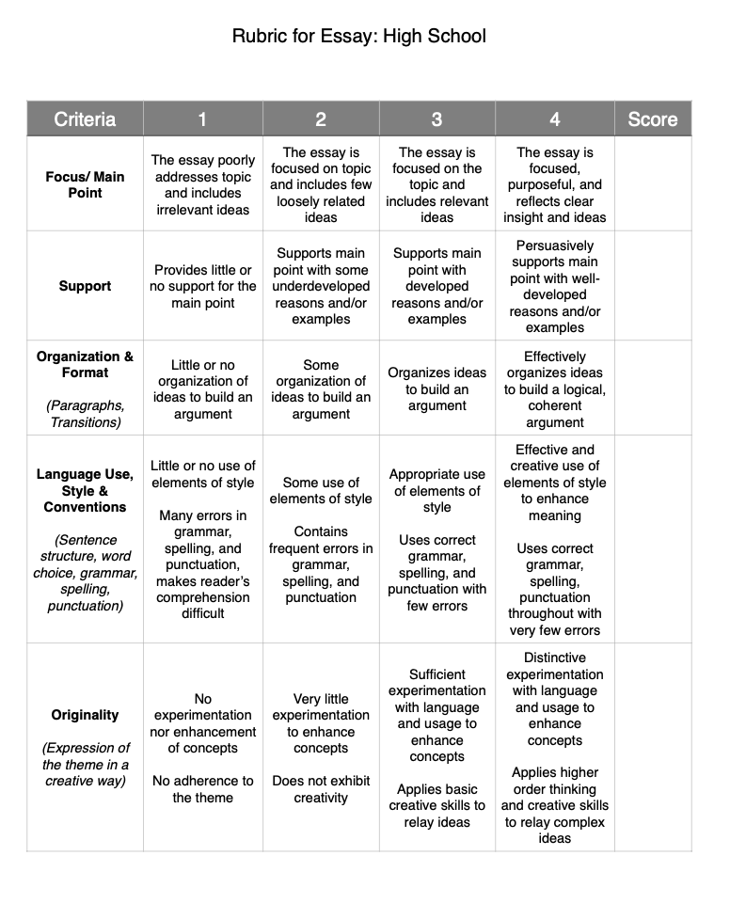

**5**

**AFFIDAVIT OF ELIGIBILITY AND LIABILITY RELEASE**

The undersigned participant of the American Association of University Women (AAUW) Women in History Scholarship Contest and the participant’s parent or guardian hereby declare that they have read and understand all of the rules and conditions for the contest and that the undersigned has met all eligibility requirements on the date their contest entry was submitted.

The undersigned and the participant’s parent or guardian represent that the essay submitted to the contest (the “Entry”) is the participant’s own original creation, and that the participant has perpetrated no fraud or deception in entering the contest or claiming any prize.

The undersigned and the participant’s parent or guardian represent and warrant that neither she/he nor any parent or guardian is an employee of AAUW, or its related, parent, affiliated and subsidiary companies, advertising and promotion agencies, or the panel of judges, nor is she/he or any parent or guardian connected with them in any way.

The undersigned and the participant’s parent or guardian irrevocably grant to AAUW, its successors and assigns and all other persons deriving rights from them, all rights, title and interest in the undersigned's Entry in perpetuity, to print, publish, broadcast, use or modify in any manner in any media whatsoever the Entry as submitted for the contest to the fullest extent permitted by applicable law.

In addition, the undersigned and the participant’s parent or guardian grant to AAUW, its successors and assigns and all other persons deriving rights from them, the right to use the participant’s name, likeness and biographical information, and city of residence for promotional purposes in any medium without compensation**,** to the fullest extent permitted by applicable law.

The undersigned and the participant’s parent or guardian hereby waive the opportunity and any right to inspect or approve any such promotion, printing, broadcast use or publication, and further release AAUW, its successors and assigns from all liability in connection with any such promotion, printing, broadcast, use or publication.

The undersigned and the participant’s parent or guardian hereby release and hold harmless AAUW and its officers, directors, employees, and agents from any and all losses, claims or damages that may result, directly or indirectly, from participation in the contest or use of the prize award. The undersigned understands that any and all local, state or federal tax liability for the award will be the responsibility of the undersigned and the participant’s parent or guardian.

The undersigned and the participant’s parent or guardian further acknowledge and agree that the contest prize is non-transferable, and that no substitution of prizes will be allowed, except by the AAUW due to the unavailability of prizes at the time of the award.



6

The undersigned and the participant’s parent or guardian understand that AAUW is proceeding with the award of any prize in the contest in express reliance on this release and the undersigned and the participant’s parent or guardian represent and agree that they are free to grant the rights set forth in this release.

The undersigned contest participant and the participant’s parent or guardian hereby attest that they have read and understand all the foregoing provisions of this affidavit and agree to be bound by the same.

**__________________________________________________________________________________________________________________ Signature of contest participant Date**

**__________________________________________________________________________________________________________________ Type or print name of participant**

**_________________________________________________________________________________________________________________**

**Contest participant’s current address**

**__________________________________________________________________________________________________________________ Telephone number email address**

**__________________________________________________________________________________________________________________**

**Signature of parent/guardian** (if contest participant is under 18 years of age) **Date**

**__________________________________________________________________________________________________________________**

**Print name of parent or guardian __________________________________________________________________________________________________________________**

**Address if different from contestant**

**______________________________________________________________**

**Email address**

7

**Scholarship Contest Dates**•

**By Monday, March 31 –Complete/Email Application, Essay and Affidavit**

Please make a copy of the application prior to completing it and share the completed copy of the application with an essay and affidavit signed by you and your parents/guardians to Sandra Martinez. You may also print, sign, scan and email to [sagaleamartinez@gmail.com](mailto:sagaleamartinez@gmail.com)

.

**April 15 – Judging**

**Judges will read essays and a winner will be selected. Contestants will be notified by email if they have received a scholarship or not by April 20**

**May 10 – Award**

**The scholarship recipient will attend the May 10, 2025 La Mesa/El Cajon general meeting to accept their scholarship and give a short overview of their future interests (approximately 5 minutes).**