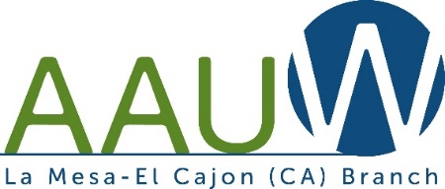
PRESS RELEASE INSTRUCTIONS
*****************************************************************************

For Immediate Release
Contact: (appropriate officer or chair)
Phone:
Address:
HEADLINE USING ALL UPPERCASE
Subtitle in Italics
Month, Day, Year, Location (including city and state)-The opening paragraph should contain a news angle or hook to pique the media’s attention and increase the chance of media coverage. This paragraph should also contain Who, What, When, Where, Why, and How.
The remainder of the body text should include any relevant information, including benefits of the event, statistics, area of impact, etc. Add quotes from branch president, community leaders, program partners or elected officials. The quote should be based on the press release topic and you should obtain the individual’s permission to use the quote.
Add Boilerplate:
La Mesa-El Cajon Branch of American Association of University Women (AAUW) has been engaged in “equity for all” efforts since the 1950’s and is one of the largest branches in the state. AAUW empowers women and girls by advocating for more women in leadership positions, closing the gender pay gap and preventing sexual harassment and discrimination. We support girls entering STEM (Science, Technology, Engineering, and Math) careers. We use research, education, and advocacy at the national, state, and branch levels to accomplish our goals. Find us on our website for more information about this dynamic organization. We are always looking for members who want to make a difference! www.lamesaelcajon-ca.aauw.net.
At the end of the release, insert three # symbols to show that the press release is complete.
# # #
******************************************************************************
NEWSPAPER CONTACTS
San Diego Union Tribune: karen.pearlman@sduniontribune.com (She covers East county in the UT)
La Mesa Courier: jeff@sdnews.com
Mission Times Courier: jeff@sdnews.com
East County Magazine: editor@eastcountymagazine.org
East County Gazette: editor@ecgazette.com
The Californian: editor@eccalifornian.com
KUSI TV: news@kusi.com

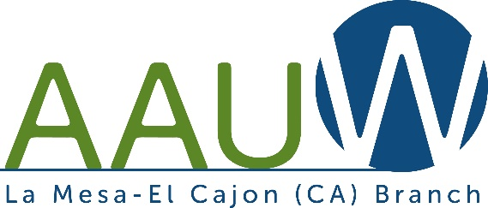
PRESS RELEASE *****************************************************************************

For Immediate Release
Contact:
Phone:
Address:

La Mesa-El Cajon Branch of American Association of University Women (AAUW) has been engaged in “equity for all” efforts since the 1950’s and is one of the largest branches in California. AAUW empowers women and girls by advocating for more women in leadership positions, closing the gender pay gap and preventing sexual harassment and discrimination. We support girls entering STEM (Science, Technology, Engineering, and Math) careers. We use research, education, and advocacy at the national, state, and branch levels to accomplish our goals. Find us on our website for more information about this dynamic organization. We are always looking for members who want to make a difference! www.lamesaelcajon-ca.aauw.net.
# # #
**************************************************************************************

